Hands-on 2:
Spring Core and Maven
Exercise 1: Configuring a Basic Spring Application:

File name: pom.xml
<project xmlns="http://maven.apache.org/POM/4.0.0"
xmlns:xsi="http://www.w3.org/2001/XMLSchema-instance"
xsi:schemaLocation="http://maven.apache.org/POM/4.0.0
http://maven.apache.org/xsd/maven-4.0.0.xsd">

<modelVersion>4.0.0</modelVersion>

<groupId>org.example</groupId>
<artifactId>Library_Management</artifactId>
<version>1.0-SNAPSHOT</version>
<name>Archetype - Library_Management</name>
<url>http://maven.apache.org</url>

<properties>
<maven.compiler.source>1.8</maven.compiler.source>
<maven.compiler.target>1.8</maven.compiler.target>
<spring.version>5.3.32</spring.version> <!-- Latest 5.x version -->
</properties>

<dependencies>
<!-- Spring Core -->
<dependency>
<groupId>org.springframework</groupId>
<artifactId>spring-core</artifactId>
<version>${spring.version}</version>
</dependency>

<dependency>
<groupId>org.springframework</groupId>
<artifactId>spring-context</artifactId>
<version>${spring.version}</version>
</dependency>

<dependency>
<groupId>org.springframework</groupId>
<artifactId>spring-beans</artifactId>
<version>${spring.version}</version>
</dependency>

<dependency>
<groupId>org.springframework</groupId>
<artifactId>spring-expression</artifactId>
<version>${spring.version}</version>
</dependency>

<dependency>
<groupId>junit</groupId>
<artifactId>junit</artifactId>
<version>4.13.2</version>
<scope>test</scope>
</dependency>
</dependencies>

</project>

File name:applicationContext.xml

<?xml version="1.0" encoding="UTF-8"?>
<beans xmlns="http://www.springframework.org/schema/beans"
xmlns:xsi="http://www.w3.org/2001/XMLSchema-instance"
xsi:schemaLocation="http://www.springframework.org/schema/beans
http://www.springframework.org/schema/beans/spring-beans.xsd">

<bean id="bookService" class="com.library.service.BookService"/>
<bean id="bookRepository" class="com.library.repository.BookRepository"/>
</beans>

File name: BookRepository.java
package com.library.repository;

public class BookRepository {
public void saveBook(){
System.out.println("Book saved to repository");
}
}
File name: BookService.java
package com.library.service;
public class BookService {
public static void issueBook(){
System.out.println("Issued book from service..");
}
}
File name: Main.java
package com.library;
import com.library.service.BookService;
import org.springframework.context.ApplicationContext;
import org.springframework.context.support.ClassPathXmlApplicationContext;
public class Main {
public static void main(String[] args) {
ApplicationContext context =new ClassPathXmlApplicationContext("applicationContext.xml");
BookService bookService =context.getBean("bookService" , BookService.class);
BookService.issueBook();
}
}
OUTPUT: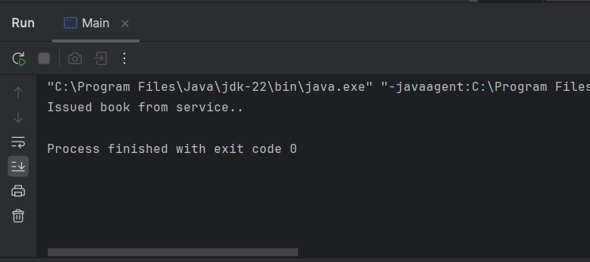

Exercise 2: Implementing Dependency Injection:
File name: applicationContext.xml:
<?xml version="1.0" encoding="UTF-8"?>
<beans xmlns="http://www.springframework.org/schema/beans"
xmlns:xsi="http://www.w3.org/2001/XMLSchema-instance"
xsi:schemaLocation="
http://www.springframework.org/schema/beans
http://www.springframework.org/schema/beans/spring-beans.xsd">

<!-- BookRepository bean -->
<bean id="bookRepository" class="com.library.repository.BookRepository"/>

<!-- BookService bean with dependency injected -->
<bean id="bookService" class="com.library.service.BookService">
<property name="bookRepository" ref="bookRepository"/>
</bean>

</beans>
File name: BookRepository.java
package com.library.repository;
public class BookRepository {
public void saveBook(){
System.out.println("Book saved to repository");
}
}
File name:BookService.java
package com.library.service;
import com.library.repository.BookRepository;
public class BookService {
private BookRepository bookRepository;
// Setter method for Dependency Injection
public void setBookRepository(BookRepository bookRepository) {
this.bookRepository = bookRepository;
}
public void issueBook() {
System.out.println("Issuing book from BookService..."); bookRepository.saveBook();
}
}
File name: Main.java
package com.library;
import com.library.service.BookService;
import org.springframework.context.ApplicationContext;
import org.springframework.context.support.ClassPathXmlApplicationContext;
public class Main {
public static void main(String[] args) {
ApplicationContext context = new ClassPathXmlApplicationContext("applicationContext.xml");
BookService bookService = context.getBean("bookService", BookService.class);
bookService.issueBook();
}
}

OUTPUT:
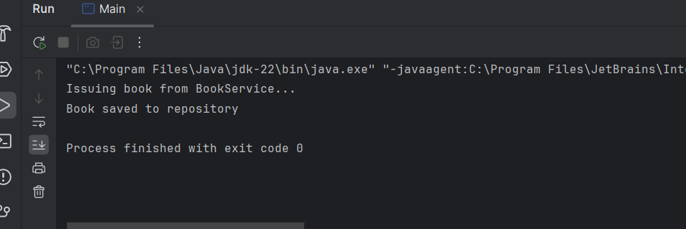

Exercise 4: Creating and Configuring a Maven Project
Add Spring Dependencies in pom.xml:
Include dependencies for Spring Context, Spring AOP, and Spring WebMVC.
File name: pom.xml
<project xmlns="http://maven.apache.org/POM/4.0.0"
xmlns:xsi="http://www.w3.org/2001/XMLSchema-instance"
xsi:schemaLocation="http://maven.apache.org/POM/4.0.0
http://maven.apache.org/xsd/maven-4.0.0.xsd"> <modelVersion>4.0.0</modelVersion>
<groupId>com.library</groupId> <artifactId>LibraryManagement</artifactId>
<version>1.0-SNAPSHOT</version>
<properties>
<java.version>1.8</java.version>
<spring.version>5.3.32</spring.version>
</properties>
<dependencies>
<!-- Spring Context -->
<dependency>
<groupId>org.springframework</groupId>
<artifactId>spring-context</artifactId>
<version>${spring.version}</version>
</dependency>
<!-- Spring AOP -->
<dependency>
<groupId>org.springframework</groupId>
<artifactId>spring-aop</artifactId>
<version>${spring.version}</version>
</dependency>
<!-- Spring Web MVC -->
<dependency>
<groupId>org.springframework</groupId>
<artifactId>spring-webmvc</artifactId>
<version>${spring.version}</version>
</dependency>
<!-- Optional: Servlet API (for web apps) -->
<dependency>
<groupId>javax.servlet</groupId>
<artifactId>javax.servlet-api</artifactId>
<version>4.0.1</version>
<scope>provided</scope>
</dependency>
</dependencies>
Configure Maven Plugins:
Configure the Maven Compiler Plugin for Java version 1.8 in the pom.xml file.
<project xmlns="http://maven.apache.org/POM/4.0.0"
xmlns:xsi="http://www.w3.org/2001/XMLSchema-instance"
xsi:schemaLocation="http://maven.apache.org/POM/4.0.0
http://maven.apache.org/xsd/maven-4.0.0.xsd">
<modelVersion>4.0.0</modelVersion>
<groupId>com.library</groupId>
<artifactId>LibraryManagement</artifactId>
<version>1.0-SNAPSHOT</version>
<properties>
<java.version>1.8</java.version>
<spring.version>5.3.32</spring.version>
</properties>
<dependencies>
<!-- Spring Context (Core container) -->
<dependency>
<groupId>org.springframework</groupId>
<artifactId>spring-context</artifactId>
<version>${spring.version}</version>
</dependency>
<!-- Spring AOP -->
<dependency>
<groupId>org.springframework</groupId>
<artifactId>spring-aop</artifactId>
<version>${spring.version}</version>
</dependency>
<!-- Spring WebMVC -->
<dependency>
<groupId>org.springframework</groupId>
<artifactId>spring-webmvc</artifactId>
<version>${spring.version}</version>
</dependency>
<!-- Servlet API for web-related tasks -->
<dependency>
<groupId>javax.servlet</groupId>
<artifactId>javax.servlet-api</artifactId>
<version>4.0.1</version>
<scope>provided</scope>
</dependency>
</dependencies>
<!-- Maven Compiler Plugin for Java 1.8 -->
<build>
<plugins>
<plugin>
<groupId>org.apache.maven.plugins</groupId>
<artifactId>maven-compiler-plugin</artifactId>
<version>3.8.1</version>
<configuration>
<source>${java.version}</source>
<target>${java.version}</target>
</configuration>
</plugin>
</plugins>
</build>
</project>

